GRANULAR FILTRATION

Settling is not sufficient to remove all particles and flocs from water. Typical overflow qualities from sedimentation tanks range from 1 to 10 NTU. Filtration, usually rapid sand filtration, is then employed for further “polishing”, i.e. to get the turbidity to lower than 0.5 NTU (as required by legislation). Rapid sand filtration after prior sedimentation is the most common configuration worldwide. Increasingly, direct filtration is being employed where the turbidity of the raw water is not high. Slow sand filtration is not very common, but there is a renewal in interest in using this as a very useful unit process when organic removal by biological means becomes important.

Sand filtration is recognized as one of the essential barriers in water treatment, a barrier to pathogens. The other barrier is disinfection. With the focus on protozoan diseases, giardiasis and cryptosporidiasis, the importance of sand filtration has once more been realized, due to the failure of disinfection to inactivate the cysts and oocysts of the protozoa. To ensure effective removal of oocysts, some water treatment plants strive to achieve a turbidity level of 0.1 NTU and initial filtrates immediately after backwashing are discarded.

There are several other filtering processes used for the separation of particles from a stream of water or sludge. Precoat filtration is mainly used in pretreatment before membrane filtration, although one form of precoat filtration, diatomaceous earth filters are commonly used in swimming pools. These technologies are being reconsidered in full-scale water treatment to counteract protozoan diseases. Vacuum filters and filter presses are used for removing water from sludges by the use of a filter cloth, which retains a layer of sludge from which water is sucked or pressed by an induced pressure difference. These units operate mainly through the use of a mechanical straining process. The emphasis in these notes will be on sand filtration.

3.1 RAPID SAND FILTRATION

Filtration is used in both water treatment and wastewater treatment as a separation process, which removes fine inorganic and organic particles from the water. Sand filters are often used in treatment of water to remove fine particles, which cannot be economically removed by sedimentation. Sand filtration is a form of granular medium filtration, in which the filtering medium consists of granular material such as sand, anthracite, activated carbon or other grains. The main applications in water treatment are rapid sand filtration and slow sand filtration.

There are a number of mechanisms, which result in the removal of particles from water during rapid sand filtration as discussed below.

Mechanical straining

Granular filters remove particles that are very much smaller than the dimensions of the interstices between their grains. Although there must be some mechanical straining effect, it accounts for only a minor part of the action of a filter. A granular filter is capable of capturing very fine particles, even in the absence of particles large enough to bridge the interstices.
Adsorption

There are three essential parts of the filtration process in a granular material. They are:

- the bed of fixed solids (consisting of the filter medium together with previously deposited impurities),
- the water passing through the interstices between the fixed solids, and
- the solid impurities suspended in the water.

Adsorption of particles of impurities onto the fixed bed (that is, the fine particles stick either to a grain of filter material or to previously deposited and adsorbed impurities) is a major factor in successful filtration through porous media. Adsorption is a process of which the efficiency depends on the surface properties of both the adsorbing matrix and the small particles that are adsorbed. There are two factors in the adsorption of a particle:

- its ability to stick to the matrix when it is brought into contact and
- its transport to a position where it either contacts the surface or comes close enough to be attracted to it.

The method of attachment of particles is similar to the process of flocculation. A small particle in close proximity to a solid surface is subject to either electrical attraction or repulsion (depending on the surface changes developed by both the particle and the surface when in contact with the water) and to the attraction caused by van der Waals forces (see Fig 2.1). It is also subject to the hydraulic forces resulting from the movement of the water. The electrical forces can either inhibit or enhance the removal of fine particles from the water as it passes through a filter. For most of a filtering period, the grains of filter material are coated with a layer of impurities and, therefore, the surface charge produced on the impurities is important in ensuring a prolonged effective filter operation before cleaning is required. If the water has been treated to give optimum destabilization of colloids for effective flocculation and sedimentation, it is likely that the remaining particles will be suitably destabilized for effective filtering.

The forces of adhesion between the deposited impurities and the filter grains can become so strong that the impurities are not readily removed during backwashing. The impurities and filter grains may then lump together to form mud-balls, which are very resistant to being cleaned by backwashing; their hydraulic behavior makes them settle in a fluidized bed of sand. Care must therefore be exercised to ensure that although the adhesion surface forces are strong enough to trap and hold impurities, they are weak enough to allow their release during backwashing.

Transport

For adsorption to occur, particles must be carried close enough to the matrix surface to become attracted and attached to it. They are carried through the interstices in the filter matrix by the water flow, which, under normal conditions, is laminar.

There are three main mechanisms by which particles are transported into contact with the filter matrix: interception, sedimentation and diffusion (see Fig 3.1).

- Interception is the process whereby a particle being carried along a streamline chances to come close enough to the surface for its attachment. If a particle of effective diameter d_{p} is moving along a streamline which passes within a distance of ¹/₂ d_{p} from a solid surface, there is an opportunity for adsorption.
- Sedimentation is the process in which a particle is deflected from the streamline path by the gravitational effect, resulting from the difference between its weight and its buoyancy. A granular filter has an action that could be considered as an irregular shallow depth sedimentation unit.
- Diffusion is the process whereby particles are randomly deflected by buffeting resulting from molecular activity (Brownian motion). This will occur under laminar flow conditions.

The effectiveness of interception and sedimentation in a filter increases with an increase in particle size, but the effectiveness of diffusion increases with a decrease in size. Thus, although a filter may remove large particles efficiently by interception and sedimentation, and very small particles by diffusion, there is an intermediate size of particle for which the removal efficiency is relatively low. For practical filters, this is about 1 – 5 micron. Considering that Cryptosporidium oocysts are about 5μ in diameter, their removal is difficult.

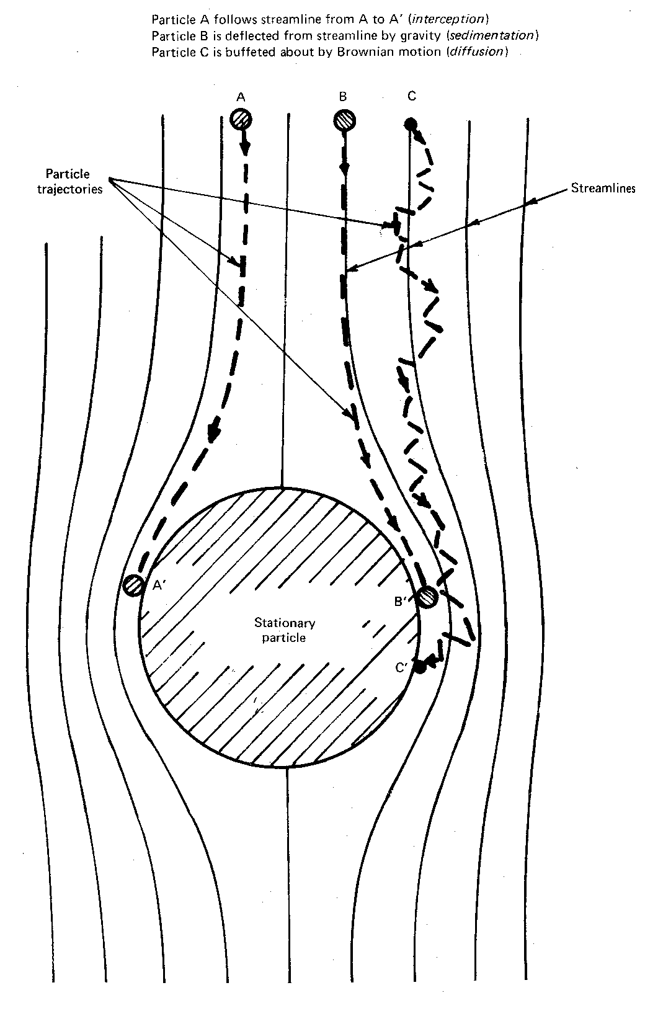

Figure 3.1 Methods of particle transport

The destabilization of colloids with adequate chemical pre-treatment is an essential aspect of rapid sand filtration.

Head loss in operating filter

For filter flow rates in the normal operating regime of 3 to 15 m³ m⁻² h⁻¹, i.e. 3 to 15 m/h approach velocity, and sand with an effective size of 0.5 to 1.0 mm, the error in assuming that the head loss is proportional to the flow rate is practically negligible. Thus Darcy’s Law,

V = K $\frac{h}{L}$ (3.1)

can be used to estimate the head loss in filter, where h is the head loss; L is the depth of filter bed over which the loss occurs; V is the velocity of the water at the filter; and K is Darcy’s coefficient of permeability.

The coefficient of permeability is a function of the density, ρ, and viscosity, μ, of the water, the size and shape of the grains in the bed, and their porosity, f (or ε as in AWWA).

Kozeny’s equation gives an estimate of the head gradient in a clean bed of sand filtering clean water as

$\frac{h}{L}$ = ${\frac{\text{kV}μ(1−f)^{2}A}{{gρf}^{3}∀^{2}}}^{2}$ (3.2)

where k is a dimensionless coefficient with a value of about 5 for most filtering conditions;
A is the grain surface area; and ∀ is the grain volume.

For spherical grains, $\frac{A}{\text{\} \} = \{ \{6\} over \{d\} \} \} \{}}$, where d is the diameter of sphere but for other shapes, $\frac{A}{\text{\} \} = \{ \{6\} over \{yd\} \} \} \{}}$, where ψ is a shape coefficient - about 0.9 for water-worn sand, 0.7 for angular sand, and 0.65 for well-shaped crushed material. If k is assumed to be 5, the head loss through a clean bed of depth L is given approximately by (Note: 180 = 5 x 6²)

h = $\frac{\text{180}}{g}\frac{m}{ρ}V\frac{(1−f)^{2}}{f^{3}}\frac{L}{y^{2}d^{2}}$ (3.3)

The two parameters relating to the bed, which have the most effect on head loss are d, the grain diameter, and f, the porosity. A decrease in either will cause an increase in head loss.

In a practical filter there is a mixture of particles sizes, the water is not clean and, for most of the time, many of the grains of filter medium are coated with impurities. The calculation of head loss is useful only to estimate the minimum head loss in a filter for a given flow. Because of the difference between practical and ideal conditions, only a moderate degree of agreement between actual and estimated head losses can be expected.

Example 3.1

A clean filter has a bed consisting of uniform, water-worn sand grains 0.7 mm in diameter. The porosity of the bed is 0.4 and the bed is 0.8 m deep. If the flow rate is 1.5 L.s⁻¹.m⁻², estimate the head loss if the viscosity of the water is 1 x 10⁻³ N.s.m ⁻².

Solution
Substituting in Eq 3.6 (converting to basic SI units) Note: μ = 1 x 10⁻³ kgm⁻¹s⁻¹, from N = kgms⁻²
Ls⁻¹ m⁻² = mm/s = 3.6 m/h
h = $\frac{\text{180}}{9\text{.}\text{81}}x\frac{1x{\text{10}}^{−3}}{[\text{1000}]}x\frac{1\text{.}5}{\text{1000}}x\frac{(1−0\text{.}4)^{2}}{0\text{.}4^{3}}x\frac{0\text{.}8}{0\text{.}9^{2}x0\text{.}{\text{0007}}^{2}}$ = 0.31 m
The effect of fouling

It has been found from experience that, as a filter bed collects impurities, the increase in the head loss is approximately directly proportional to the amount of impurities collected. The head loss in a filter during operation with a uniform quality of feed, can then be written as

h = V(a + b ∀) (3.4)

where V is the approach velocity of the water; ∀ is the volume of water filtered through unit area of bed since the last backwash; and a and b are parameters depending on the size and shape of the material, and the quality of the applied water.

Example 3.2

A filter has a head loss of 0.3 m when newly washed, and 1.3 m after 24 hours, when operating at a rate of 1.5 Ls⁻¹m⁻². Estimate the head loss both immediately after backwash and 10 hours later, if the same water is applied at a rate of 2 Ls⁻¹m⁻².

Solution

Substitution of the data in the formula gives two simultaneous equations

0.3 = $\frac{1\text{.}5}{\text{1000}}$ [a + (0 x b)]

1.3 = $\frac{1\text{.}5}{\text{1000}}$ [a + ($\frac{1\text{.}5}{\text{1000}}$ x 24 x 3600 b)]

Solution of these simultaneous equations gives a = 200, b = 5.14

For the new condition, substitution gives

h_{o} = $\frac{2}{\text{1000}}$ [200 + (0 x b)] = 0.4 m and

h₁₀ = $\frac{2}{\text{1000}}$ [200 + ($\frac{2}{\text{1000}}$ x 10 x 3600 x 5.14)] = 1.88 m

Head loss when backwashing

The total head loss during a backwash is equal to the sum of head losses in the sand bed, gravel bed and distribution system.

In the sand bed, the head loss follows Darcy’s law for low flows. Water flowing upwards through a granular bed creates hydraulic drag forces on the grains. As long as a grain is in contact with other grains, the resultant of the intergranular forces and drag forces on the grain is equal to the buoyant weight of the grain. If, however, the grain is freely suspended in the water, the intergranular forces must be zero and the drag force then equals its buoyant weight.

The drag force acts on the grains and there is an equal and opposite reaction on the water. This gives rise to a pressure loss as the water passes through the granular bed. It follows that the pressure loss is given by

δP = (W_{b} - F_{f})/A

where δP is the pressure loss in the bed; W_{b} is the buoyant weight of bed material; F_{f} is the total of granular forces acting on the floor of the bed; and A is the horizontal area of the bed.

As F_{f} cannot be negative, the maximum value of δP is W_{b}/A. When the flow exceeds that at which the Darcy pressure loss (ρg x head loss) is equal to the buoyant weight of the grains in unit area, the sand bed expands and thus increases the porosity. Hence, the pressure loss remains equal to, or less than, the buoyant weight of the grains per unit area. When the porosity has increased so that the grains in the bed are free to move while suspended by the hydraulic forces, the bed is fluidized. Fluidization is a special case of hindered settling.

The total head loss in a fully fluidized sand bed is approximately equal to the original depth of the bed. This is coincidental, because the apparent relative density of sand is about 1.65 (that is, 2.65 - 1) and, with a porosity of about 0.4, the volume of the sand grains is about 0.6 times the volume of the bed.

The pressure corresponding to the buoyant weight of the grains per unit area therefore corresponds to that caused by a head of water about 0.6 x 1.65 times the depth of the bed.

The empirical Richardson-Zaki formula relates the porosity and upflow velocity in a fluidized bed:

V_{s} = V_{p} (1 - C)^{n} (3.5)

where V_{s} is the hindered settling velocity (which, in a fluidized bed, is equal to the upflow velocity); V_{p} is the settling velocity of a single particle (of mean size); C is the volumetric concentration (1 - porosity); and n is an index which depends on the nature and grading of the grains.

The value of n varies from about 2.5 for particles, which settle with a turbulent wake to 4.65 for spherical particles around which the flow of water is laminar. For filter sand, the value is usually in the range 3.6 to 4.5.

As the magnitude of the upflow velocity, V_{s}, in the fluidized condition increases, so the porosity increases and the concentration decreases. If the initial bed depth and concentration are L and C_{o} respectively, the depth of the fluidized bed is LC_{o}/C. The percentage expansion of the bed is equal to 100 (C_{o} - C)/C.

The upflow through a bed is inherently unstable. The head loss over a given depth is proportional to the concentration, and therefore decreases as the flow increases. Any local increase in flow reduces the local concentration. Therefore, the resistance to flow is reduced and this tends to cause a further increase of flow. Uneven backwashing of filters results from this phenomenon, and controls external to the bed must be provided.

The external control of flow is provided by the head loss in the finer layers of gravel in the sand support or by the distributing orifices in the filter floor, or both. The head loss through these must be large enough to control the flow, despite the unstable nature of the granular bed.

The viscosity of water varies with temperature. Therefore, lower flow rates are required with very cold waters, and higher flow rates with warm waters (as found in hot climates), to produce the same sand expansion and washing efficiency.

Example 3.3

A filter bed of uniform sand has an operating depth of 0.6 m at a porosity of 0.41. When backwashed at a rate of 7.2 L/s.m² at 15˚C, the bed expands to a depth of 0.72 m and, at 16.1 L/s.m², it expands to a depth of 0.906 m. Estimate the backwash rate required at the same temperature to cause 30 per cent expansion.

Solution
Substitution of the data in the Richardson-Zaki equation, V_{s} = V_{p} (1 - C)^{n}, gives

7.2 = V_{p} ${\left[1−\left(0\text{.}\text{59}x\frac{0\text{.}6}{0\text{.}\text{72}}\right)\right]}^{n}$

16.1 = V_{p} ${\left[1−\left(0\text{.}\text{59}x\frac{0\text{.}6}{0\text{.}\text{906}}\right)\right]}^{n}$

Divide LHS by LHS and RHS by RHS, which gives

0.447 = ${\left(\frac{0\text{.}\text{508}}{0\text{.}\text{609}}\right)}^{n}$

Therefore, n = 4.44.

Substitution of this value in one of the above equations gives

7.2 = V_{p} ${\left[1−\left(0\text{.}\text{59}x\frac{0\text{.}6}{0\text{.}\text{72}}\right)\right]}^{4\text{.}\text{44}}=V_{p}(0\text{.}\text{508})^{4\text{.}\text{44}}$

from which V_{p} = 145.6 mm/s.
Now, for 30 per cent expansion,

V_{s} = 145.6 ${\left[1−\left(0\text{.}\text{59}x\frac{\text{100}}{\text{130}}\right)\right]}^{4\text{.}\text{44}}$ = 9.93 mm/s

Operation of Rapid Sand Filters

Rapid filtration is used as the final clarifying step in municipal water treatment plants. If the raw water has turbidity in excess of 10-20 NTU, flocculation and sedimentation unit processes should be employed before the rapid filters must be provided. There is limited biological action in conventional rapid filters. Some nitrification by chemotrophs occurs when the oxygen content is adequate, and the retention time is sufficient.

The working of a rapid gravity filter is explained below with reference to Figures 3.2 and 3.3. When the filter is in a working condition, only valves 1 and 4 are kept open and all others are kept closed.

Backwashing

Water that passes through the filter medium, supporting layer, and underdrain, experiences frictional loss of resistance known as headloss. When the head loss exceeds 1.5-2.5 m, the filter needs cleaning. The first operation is to close valves 1 and 4 (Figure 3.2) and allow the filter to drain until the water lies a few centimeters above the top of the bed. Then valve 5 (Figures 3.2 and 3.3) is opened, and air is blown back through a compressed air unit at a rate of about 1 - 1.5 m³ free air/min. m² of bed area for about 2-3 minutes, at a pressure of 20-35 kN/m². The water over the bed quickly becomes very dirty as the air-agitated sand breaks up surface scum and dirt. Following this, valves 2 and 6 are opened, and an upward flow of water is sent through the bed at a carefully designed high velocity. This should be sufficient to expand the bed (20-50% ) and cause the sand grain to be agitated so that deposits are washed off them, but not so high that the sand grains are carried away in the rising upwards flush of water.

After the washing of the filters has been completed, valves 2 and 6 will be closed, and valves 1 and 3 opened. This restores the inlet supplied through valve 1. The filtered water is wasted to the gutter for a few minutes after this, until the required quality is achieved. Ultimately, valve 3 is closed and valve 4 is opened to get the filtered water again. The entire process of backwashing the filters and restarting the supplies takes about 15 minutes. The specified minimum backwash time for a rapid filter is 5 minutes. The amount of water required to wash a rapid filter may vary from 3-6% of the total amount of water filtered.

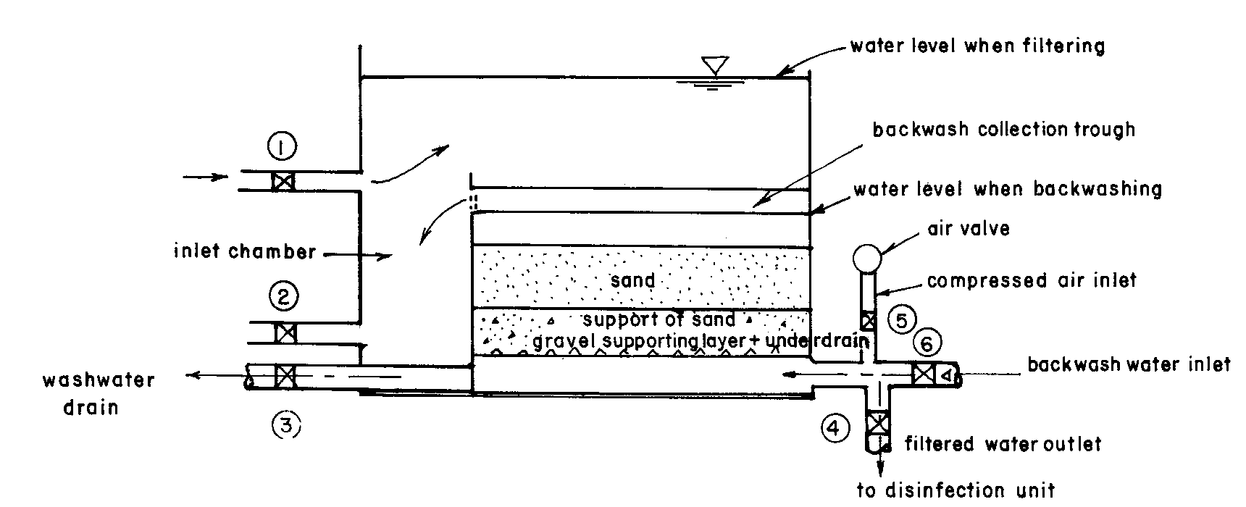

Figure 3.2 Diagrammatic section of a rapid sand filter

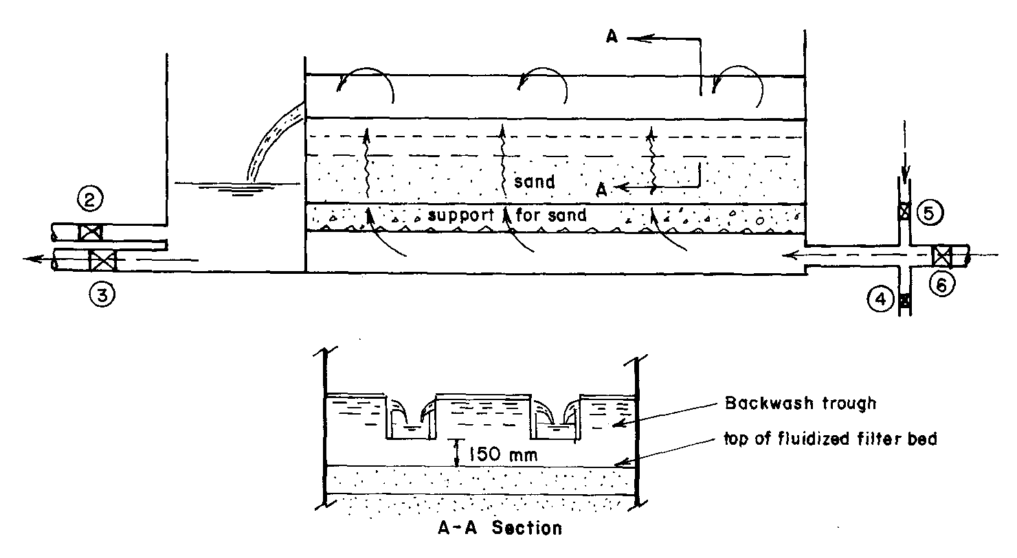

Figure 3.3 Diagrammatic section of a backwash system
Upward wash water rates are usually of the order of 0.3-1.0 m/min. It is usually more economical to use gravity flow from a large storage tank, since the backwash flow rates are high. Keeping such a tank topped up by a relatively small, continuously running pump drawing from the filtered water supply can minimize energy requirements. The washwater tank should have a capacity to provide a minimum of one filter wash of 10 minutes duration. It should be capable of being refilled in 60 minutes.

If there is significant particle retention at the surface of the bed, it is recommended to have a surface wash. Surface wash is achieved by an additional c.0.2 m³/min-m² of water jetted onto the surface of sand at 150-450 kN/m². Different filter backwash methods and the recommended design valves are summarized in Table 3.1.

The underdrain system of a filter is an important component in the design and operation. The selection is based on the filter type and size, media characteristics, and the selected method of backwashing. The underdrain should contain a central manifold, with laterals that are either perforated or have umbrella-type strainers on top. Other types that may be used include clay tile blocks, precast concrete laterals, false bottoms with strainers, and porous plates, etc. The selected underdrain system, while ensuring uniform flow distribution of the backwash, should ensure durability, reliability, and cost-effectiveness.

Table 3.1. Recommended design values for various backwash methods
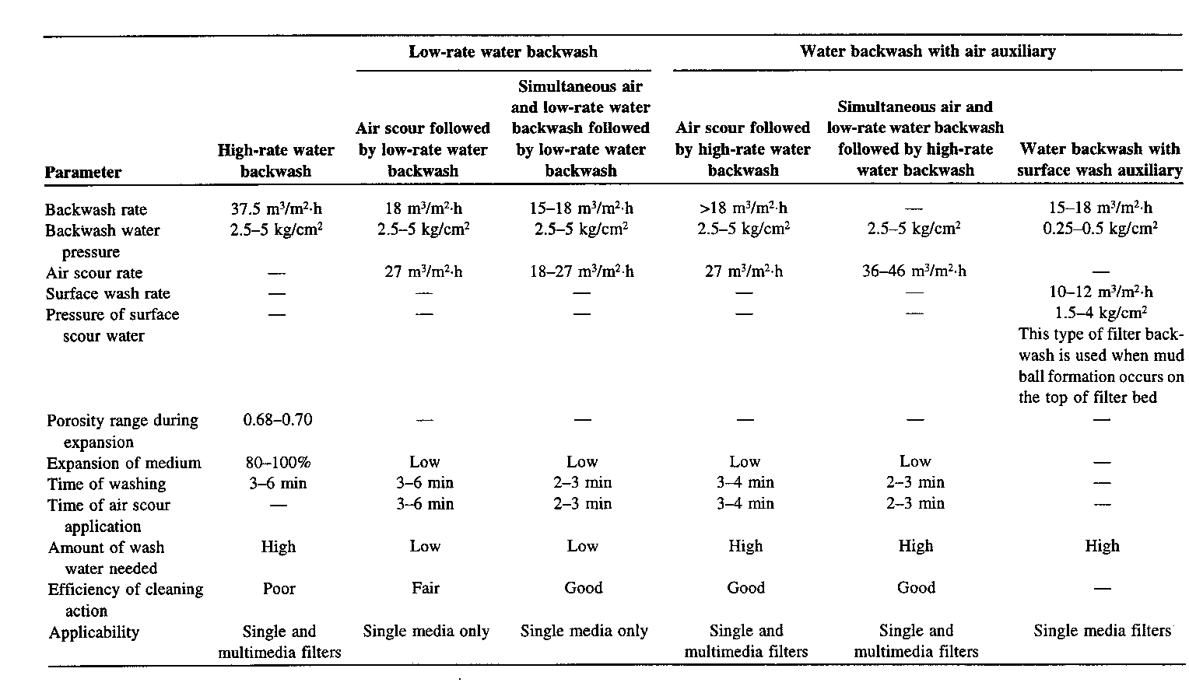

Filter Underdrains

There are two methods of keeping a uniform flow distribution of the backwash water inside the filter cell as described below.

1. By making the orifice or slits in the filter underdrain system small enough to introduce a controlled headloss.
2. By decreasing the flow velocity of the pressurized conduit upstream of the underdrain system so that the hydraulic grade and energy lines of the flow entering the underdrain system are fairly uniform.

False-bottom under drain systems are preferred due to reliable performance and low maintenance costs (Kawamura, 1991). Table 3.2 gives the typical design parameters of an underdrain system (lateral manifold system) for a small rapid sand filter.

Table 3.2 Design Criteria for Underdrains (NWS & DB, 1988)

Criterion Value

Minimum diameter of underdrains 20 cm
Diameter of the perforations 6-12 mm (suggested at a slight angle to the vertical axis of the pipe)
Spacing of perforations along laterals 7.5 cm for 6 mm perforations
20 cm for 12 mm perforations
Ratio of total area of perforation to 0.25 for 6 mm perforations
total cross-sectional area of laterals 0.50 for 12 mm perforations
Ratio of total area of perforation to 0.003
the entire filter area
Length to diameter ratio of the lateral 60:1
Maximum spacing of laterals 30 cm
Cross-sectional area of the manifold 1.5-2.0 times the total area of laterals
Velocity of the filtered water outlet 1.0-1.8 m/s

Multimedia Filters

The conventional rapid filter generally uses sand with an effective size of 0.6 -1.2 mm and a uniformity coefficient of 1.5 - 2. The uniformity coefficient is the ratio of the screen size, which will pass 60% of the material to the size, which will pass 10%.

Backwashing results in the filter media being stratified with the finer medium remaining at the top and the coarser medium at the bottom of the filter bed. This makes only the top fine sand portion effective in filtration. To overcome this problem, two alternatives have been proposed: dual or multimedia filtration; or coarse-size, narrowly graded media filtration.

The conventional approach to multimedia filtration is to have three layers of material: coarse (1mm) anthracite on top, sand of 0.5mm in the middle and 0.25mm garnet at the bottom. The size and specific gravity are carefully selected to minimize intermixing. The commonly used media are anthracite coal and sand. The difference in densities: c. 1500 kg/m³ of anthracite, 2500 kg/m³ of sand and 3300 kg/m³ of garnet, ensures that these layers maintain their position also during backwashing.

Extensive research has been carried out to study the advantages and disadvantages of intermixing of filter media in dual media filtration. While some researchers feel that the grain size of coarse anthracite and fine sand should be chosen in such a way that the intermixing at the interface is minimized, others believe that controlled mixing among filter media is beneficial. A detailed design of media is discussed in the literature (Vigneswaran et al., 1983; Mazumdar, 1984).

As a result of the search for a dual-media filter in which interface intermixing does not occur, a new type of filter called the flotofilter has been introduced. The flotofilter uses synthetic plastic beads as the filter medium. Polypropylene is the coarse medium and polystyrene is the fine medium (Werellagama, 1993). Both the media have a specific gravity less that water, hence the bed floats in water. Polypropylene is much more dense than polystyrene, hence it forms the lower part of the floating filter bed. As the coarse medium is at the bottom, the filtration is upflow. This filter needs an upper retention grid to prevent the loss of media with filtered water. Due to the large density difference, the two media do not intermix even under severe agitation, leaving a clear media interface after backwashing. This eliminates the most common operational problem encountered in conventional multimedia filters. Also, as there is a buffer zone of water between the floating bed and the filter inlet, the bed is not disturbed due to the turbulent conditions in the underdrain system. This permits the use of a very simple underdrain system, resulting in both capital and operational cost savings. Since the two media are floating, they can be fluidized using much lower energy than conventional dual-media filters. This results in considerable energy and water saving during the backwashing of the filter. Experiments carried out in France (Ben Aim et al., 1993) and in Australia (Vigneswaran and Ngo, 1993) have indicated that this can be successfully used as a static flocculator and/or prefiltration unit prior to the direct filtration unit.

Improvements on Flow Rate

Conventional rapid filtration operates at a constant rate of approximately 5 m³/m².h. Research work on the variation of flow rate has indicated that high-rate filtration and declining-rate filtration are advantageous for most cases. If it is possible to achieve the desired filtrate quality with a higher filter rate at an operational and maintenance cost comparable to that of a conventional rapid filter, then one could achieve a significant capital saving by using a high-rate filter. Similarly, research has indicated that declining-rate filtration produces a better effluent quality than the conventional process. Therefore, if one could obtain the same amount of filtered water with equal capital investments, then declining-rate filtration would have a definite advantage over conventional rapid filtration. Another advantage of using declining-rate filtration is that it does not require automatic rate control.

The concept of declining-rate filtration is not new. Basically, no rate controller is used in this system, and instead a fixed orifice replaces it. The filtration rate in this system is allowed to decline from a maximum value at the beginning of the run, when the filter is clean, to a minimum value at the end of the filter run, when the filter is in need of backwashing. In practice, several (a minimum of four) filters are used in parallel, and the water level is maintained essentially at the same level in all four. As they will be in different stages of backwashing, flow rate differences will be evened out.

High-rate filtration, in which the filtration rate is about 10-15 m³/m².h, as compared to the rate of conventional rapid sand filtration, which is of the order of 5.0 m³/m².h, is useful in upgrading existing plants. Such high filtration rates are possible, thanks to the development of (1) dual-media or multimedia; and (2) control of flocculation by polyelectrolytes, which produce relatively less sludge. High-rate filters with dual or coarse-medium arrangements have been successfully used in developed countries. This could be one of the economic solutions for the expansion of existing water treatment plants and for the construction of new plants. The filters should be designed to operate at the highest practical rate. The design should be such that even with the higher frequency of washing, they are more economical. Here, more attention should be paid to the selection of the filter media and filtration rate so that the filtrate quality meets the required standard.

Upflow filtration

- The flow in conventional rapid filtration is in the downward direction. The major disadvantage in this process is that the flow meets the fine sand before reaching the coarse sand that is found at the bottom layer (as a result of non-uniformity and stratification during backwashing). If one inverts this flow to an upward direction, a better use of the filter media can be achieved. One could then use ungraded sand to provide a larger range of sizes. This type of upflow grid filters has been extensively used for filtration of water for municipal and industrial supplies in Europe, Africa and America (Landis, 1966; Okun, 1967). Operation without grids has also met with considerable success in South Africa. (Van der Merwe and van Leeuwen, 1991).

3.2 DIRECT FILTRATION

Conventional water treatment plants generally use unit operations such as rapid mixing, flocculation, sedimentation, filtration, and disinfection. Depending on the quality of the water, one or more unit operations can be eliminated, thereby achieving a cost-effective water treatment. Direct filtration is one such method. Filters used in direct filtration thus differ little from those for conventional treatment in construction. The primary difference in the operation of the two systems is related to solids storage capacity and backwashing requirements. Different direct filtration flow schemes are presented in Figure 3.4.

Direct filtration was first explored during the early 1900s, but these attempts were not successful, due to the rapid clogging of the sand beds. The development of coarse-sand filters and dual-media filters has made it possible to store greater amounts of floc within the filter bed without excessive headloss, and has thus increased the feasibility of the direct filtration process. Further advances in filter design and the availability of a wider selection of chemical coagulants and polyelectrolytes have resulted in a variety of filtration systems being designed in which coagulating chemicals are employed. The flocculation basin is either eliminated or reduced in size, and the sedimentation basin is not utilized. Such processes thus have only screening, rapid mixing, and a short time of flocculation prior to filtration. All suspended solids and flocs formed are deposited in the filter, which is usually a multi-media, granular bed containing coal, sand, and perhaps other media.

The American Water Works Association (AWWA) Filtration Committee (1980) did a worldwide survey of 70 operating and pilot plants. This indicated that waters with less than 40 units of color, turbidity consistently below 5 NTU, iron and manganese concentrations less than 0.3 mg/L and 0.05 mg/L, respectively, and algal counts of up to 2000 per mL (measured in absorption units at 1000 nm) appear to be perfect candidates for direct filtration. Turbidity and color removals are consistently attained in this process. By efficient post-chlorination, bacteria and virus removal problems can be eliminated. Most of the literature favors the use of dual or mixed media for direct filtration.

Direct filtration can successfully be used for low-turbid waters, because of its lower capital and operational cost. It does not require any sophisticated equipment, although skilled operators are need in order to monitor the filters. Attention should be paid to the possibility of poor bacteriological quality of the filters in case of highly polluted raw water.

Design Principles

Since optimum design parameters depend greatly on the nature of the water to be treated, pilot studies are required to determine the appropriate type of coagulant and coagulant-aid, and the media composition, size, and depth. Some guidelines are given below.

- Filter media Can be single, dual, or mixed media, but usually dual and mixed media are preferred in direct filtration. Gadkari et al. (1980) recommend dual-media with bituminous coal or anthracite coal. Deeper filters with greater filter medium depths are preferred (King and Amy, 1979). The finest media possible should be selected to minimize chemical dosages. Within reasonable limits, coarse filter beds can produce the same quality filtrate as finer beds, but more polymer is required. Fine filter media are supported on a gravel bed. This is preferred to direct support on bottoms equipped with mechanical strainers or nozzles, which are not recommended (Culp, 1977).
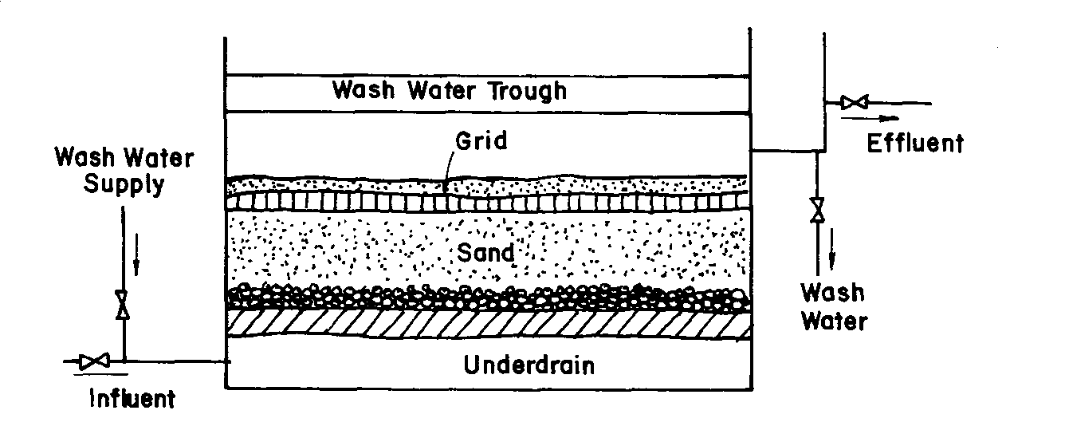

Figure 3.4 Direction filtration flow schemes

- Rapid mixing The rapid mixing process for direct filtration usually does not differ much from that used for conventional plants.
- Filtration rate 10-15 m³/m².h (constant-rate operation). A rate of 12 m³/m².h is usually adopted. Recent studies have shown that higher filtration rates are possible (up to 20 m³/m².h) with low turbid waters (Murray and Roddy, 1993a).
- Flocculants The type of flocculent is the most important parameter and should be experimentally evaluated initially. Alum has been utilized with success in many installations. Dosages of 5-10 mg/L can be effective for direct filtration of waters of various turbidities (Adin et al., 1979). However, more recently it has become apparent that a carefully selected cationic polymer may have considerable advantages in some situations. Polyelectrolyte doses for uncolored water may frequently vary from 0.05-1.0 mg/L when used as primary flocculants (essentially cationic), and may be less when used in addition to alum for the treatment of organic contaminated water (Adin et al., 1979). The general range of cationic polymer dosage used as the primary coagulant is 0.1-5 mg/L (Culp, 1977). Murray and Roddy (1993b) indicated that cationic polymer together with alum will not only increase flow rate, but also significantly increases the filter run time. Nonionic polymer and flocculation time were found to be very important.
- Backwash method Any conventional washing procedure can be used. The usual backwashing rate is 37.5-60 m³/m².h. In the case of dual-media and multi-media filters, the backwashing rate should be chosen in such a way as to minimize the intermixing of media. Details are given elsewhere (Baumann, 1978; Kawamura, 1975). The total backwash volume can be reduced by a combined air-water backwash method. Direct filtration needs frequent backwashing. When a plant contains more than four direct filtration units, inter-filter backwashing can be used. Cleasby (1993) recommends an inlet restriction as the method of flow control when inter-filter backwashing is used.
- Filter-run length Filter-run length depends on the raw water characteristics, the coagulant dose, the mixing energy input for floc formation (extent of pretreatment), the media size, the filtration rate, etc. As a guideline for design, the design parameters should be chosen in such a way that the filter run is at least 12 hours.
- Head requirement Since the filtration rate declines with time in a direct filtration plant, the total head requirement for a direct filtration plant is less than that for a constant-rate filtration plant with the same flow rate. The head previously consumed in underdrains and piping during the early high-rate part of the filter cycle decreases with the square of the filtration rate, and becomes available to overcome the clogging headloss late in the cycle. Also, the headloss due to dirt accumulation is reduced as the rate declines. The total head requirement is typically about two-thirds of that required for a constant-rate plant (Cleasby, 1993).
- Use of a standby filter A standby filter in a bank of declining rate filters is often advisable. This one filter remains off-line after it is backwashed and is brought on-line as the next dirty filter needs to go off-line for backwashing. This arrangement has two other advantages besides avoiding the spikes in level and filtrate turbidity. First, the filter that goes off-line for backwashing can be allowed to continue to filter after the inlet flow is stopped. It will slowly drop in level as it filters to the clear well. This may even take more than an hour in some cases. By doing this, the pretreated water above the filter is not wasted in the desire to finish the backwash operation in a hurry. Also, due to the reduction in spike, the filter box depth can be reduced. The clean filter will come online with a lower total head and therefore will start at a lower filtration rate. Such use of a standby filter means that the extra filter is not truly redundant (standby) as intended by the regulations (Cleasby, 1993).

Lab tests for direct filtration http://www.phippsbird.com/filtrat.html

3.3 SLOW SAND FILTRATION

In rural areas, especially in developing countries where land is plentiful, the slow sand filter can be used with success if the raw water is not highly turbid. It is well suited for turbidities less than 50 NTU. In case of highly turbid water, one has to have pretreatment prior to slow sand filtration. The schematic diagram of a simplified slow sand filtration plant, serving 1,500-20,000 people, is presented in Figure 3.5.

Principle and operation of slow sand filters

Water is purified by passing it through a bed of fine sand at low velocities (0.1-0.3 m³/m².h), which causes the retention of suspended matter in the upper 0.5-2 cm of the filter bed. By scraping out this top layer, the filter is cleaned and restored to its original capacity. The interval between two successive cleaning’s varies from a few weeks to a few months, depending on the raw water characteristics.

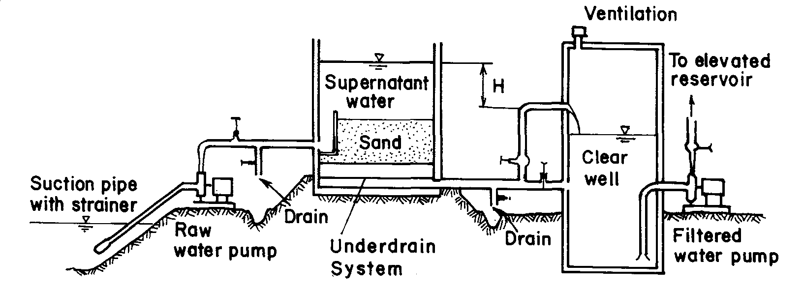

Figure 3.5 Simplified operation of slow sand filter

The removal mechanisms of particles in a slow sand filter include mechanical straining, sedimentation, diffusion, and chemical and biological oxidation. Coarse and fine particles of suspended matter are deposited at the surface of the filter bed by the action of mechanical straining and sedimentation, respectively, while colloidal and dissolved impurities are removed by the action of diffusion. By chemical and biological oxidation, the deposited organic matter is converted into inorganic solids and discharged with filter effluent. Microbial and biochemical processes, and hence the removal of impurities, take place mainly in the top zoological layer of the filter bed (known as the “Schmutzdecke”).

The important design parameters of a slow sand filter are the depth of the filter bed, filter media size, the filtration rate, and the depth of the supernatant water level. As far as possible, these design parameters should be based on experience obtained from existing treatment plants that use a raw water source of similar quality. In the absence of reliable data from such existing treatment plants, pilot plants can be used to determine suitable design criteria. The values presented in Table 3.3 can serve as helpful guidelines.

Table 3.3 Design criteria for slow sand filters

Design parameters Recommended range of values

Filtration rate 0.15 m³/m².h (0.1-0.2 m³/m².h)
Area per filter bed Less than 200 m² (in small community water
supplies to facilitate manual filter cleaning)
Number of filter beds Minimum of two beds
Depth of filter bed 1 m (minimum of 0.7 m of sand depth)
Filter media Effective size (ES) = 0.15-0.35 mm
Uniformity coefficient (UC) = 2-3
Height of supernatant water 0.7-1 m (maximum 1.5 m)
Underdrain system
Standard bricks
Precast concrete slabs Generally no need for further hydraulic calculations
Precast concrete blocks with holes on the top
Porous concrete
Perforated pipes (laterals and manifold type) Maximum velocity in the manifolds and in laterals = 0.3 m/s
Spacing between laterals = 1.5 m
Spacing of holes in laterals = 0.15 m
Size of holes in laterals = 3 mm

Since the purification mechanism in a slow sand filter is essentially a biological process, its efficiency depends upon a balanced biological community in the “Schmutzdecke”. Therefore, it is desirable to design the filters to operate as far as possible at a constant rate. However, the operation of slow sand filters in most developing countries is intermittent due to the financial difficulties in employing operators to run the plants around the clock. But the intermittent operation causes deterioration in effluent quality because during stoppages the microorganisms causing bacteriological degradation of trapped impurities lose their effectiveness. Intermittent operation disturbs the continuity needed for efficient biological activity.

One way of overcoming this problem is by allowing the filter to operate at a declining rate after a cycle of constant rate filtration. Declining rate filtration gives an additional water production of 0.5 and 0.7 m³/m² (of filter area), with a declining rate operation for 8 or 16 hours after 16 or 8 hours of constant rate, operation respectively. The effluent achieved during this operation is generally satisfactory. Moreover, the declining-rate model may be applied during night-time, resulting in significant savings of labor.

Cleaning of slow sand filters

Before cleaning a slow sand filter, floating matter such as leaves and algae that may cause nuisance should first be removed by raising the water level in the unit to flush the floating matter over the weir. Then the water level in the bed is lowered to about 0.1-0.2 m below the sand surface by closing the inlet valve and opening both the supernatant water drain valve and the valve on the underdrains. The filter bed is then cleaned by rapidly scraping off the top 1-2 cm of the bed, in view of minimizing the interference with the filter microbial activity. When one unit is shut down for cleaning, the others are run at a slightly higher rate to maintain the output of the plant.

After cleaning, the unit is refilled with water through the underdrains. This water can be obtained from an overhead storage tank or by using filtered water from an adjacent filter. The temporary reduction of plant output due to this method should be taken into account when the clear-water storage tank is designed, assuring that sufficient water is available for the users.

Before starting operating, the filter needs a period of at least 24 hours to allow for re-ripening of the bed. After this period, the microorganisms usually reestablish to be able to produce an acceptable effluent. In cooler areas, the ripening may take a few days. Even then, if the turbidity of the effluent is sufficiently low, the water supply can be resumed after a period of one day, after adequate chlorination (Visscher, 1990).

Table 3.4 gives a comparison of the characteristics of the rapid filters (both pressure and gravity types) with slow sand filters.

Costs of slow sand filters

The construction cost of an open slow sand filter excluding pipes and valves has two components, namely, (1) the floor, underdrains, sand, and gravel; and (2) the walls of the filter box. The cost of labor and land is usually less important. In rural areas, the cost of land rarely exceeds 1% of the total construction cost. However, in densely populated areas, the somewhat larger areas required for slow sand filter plants can be a problem (Visscher, 1990).

The construction cost of small-and-medium-sized slow sand filters are often less than that of other types of treatment. Construction of a slow sand filter in India is less expensive than a rapid sand filter up to a capacity of 3000 m³/d. However, if recurrent costs for operation and maintenance are taken into account, the balance shifts to 8000 m³/d. Using cheaper materials like ferro-cement and less expensive drainage systems will reduce the cost of slow sand filtration (Visscher, 1990).

In Colombia, the new slow sand filtration plants are competitive with conventional treatment plants. Even conversion of conventional plants into slow sand filtration plants has been cost-effective. For example, in a suburb near Cali, operation and maintenance of a conventional treatment plant cost U.S. $1240/month. Because of the increasing cost of chemicals, it was decided to reconstruct the plant and adopt slow sand filtration as the main treatment. Most of the existing structure could be used, holding the cost of reconstruction to as low as U.S. $7000. The oversized water storage tanks were changed into slow sand filters. Operation and maintenance costs are now U.S. $240/month (Visscher, 1990).

Table 3.4 Comparison of Slow Sand Filters and Rapid Sand Filters

Rapid filter

Characteristic Slow sand filter Gravity Pressure

Filtration rate 2-5 m³/m².d 120-360m³/m².d

Size of bed Large (2000 m²) Small (100 m²)

Depth of bed 300 mm gravel, 1 m sand 500 mm gravel, 0.7-1.0 m sand,
unstratified stratified; in some cases sand and
anthracite are used as dual media

Effective size of sand 0.35 mm 0.6-1.2 mm

Uniformity coefficient 2-2.5 1.5-1.7

Head loss Up to 1 m Up to 3 m

Length of run 20-90 days 1-2 days

Method of cleaning Scrape off top layer Backwash with water and
and wash (or replace air + water scour and in some cases
with new sand) surface scour

Washwater consumption 0.2-0.6% of filtered water 3-6% of filtered water

Penetration of suspended solids Superficial Deep
through the filter bed

Pretreatment by coagulation No Yes Yes

Covered construction No Optional Yes

Visible operation Yes Yes No

Capital cost High High Medium

Operating cost Low High High

Skilled supervision Not required Required

Adjusting the quality of filtrate Difficult Can be done quickly

Bacteria removal 99.99% 90-99%

Advantages and disadvantages of slow sand filters

Simplicity of design and operation and minimal requirements of power and expensive chemicals make the slow sand filter an appropriate technique for the removal of organic and inorganic suspended matter as well as pathogenic organisms present in surface waters of rural areas in developing countries. Sludge handling problems are also minimal. Close control by an operator is not necessary, which is important to small communities because an operator may have several responsibilities. Design experience in America shows that the slow sand filter is more than 99.9% efficient in removing Giardia cysts and coliform bacteria, and provides a stable effluent quality with a low operating budget (Seelaus et al., 1986). It has the added advantage of being able to make use of locally available materials and labor.

However, slow sand filtration has certain limitations. The requirements of a large area, large quantities of filter medium, and labor for the manual cleaning are the major disadvantages. These limitations do not apply to the rural areas in the developing world where land and unskilled labor are readily available.

Design approach to sand filters

- Start all calculations on the basis of 1m² of filter area.
- Sand filter pressure drop over a clean filter can be calculated using either the Kozeny or Rose equations. This is calculated from some predetermined maximum rate of filtration.
- The pressure drop resulting from fouling then needs to be added as a function of time. We now have a linear function between pressure drop (or throughput) and operating time, increasing until some unacceptable high pressure drop (or low throughput). (The bracketed parts refer to conditions under constant head filtration.)
- The throughput rate over the operational period can be determined as the product of (average) throughput rate and time.
- The backwashing volume of water necessary can be calculated from the backwash velocities required and the period required for backwashing.
- The actual throughput per cycle (net production) is then calculated by subtracting the amount of water required per backwash. If additional water is wasted, this also needs to be subtracted.
- The total cycle length is the filtration time + backwash time + downtime/cycle
- The average throughput rate can be calculated from the net production divided by the cycle length.
- The water demand divided by the average throughput provides the required filter area.

Important emerging issues

The removal of protozoan ova; direct filtration design; upflow filtration; continuous backwashing during filtration; floating media; increased backwashing and flushing on water quality; other forms of filtration to replace sand filtration; biological rapid sand filtration, etc.

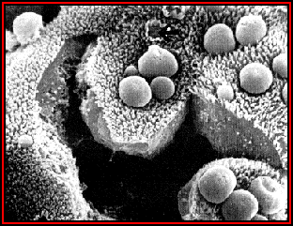 Cryptosporidium oocysts

REFERENCES

Adin, A., Baumann, E. R. and Cleasby, J.L., The application of filtration theory to pilot-plant design, J. AWWA, 71(1), 17, 1979.
Amirtharajah, A., Optimum backwashing of sand filters, J. Environ. Eng. Div. ASCE, 104(EE5), 917, 1977.
Amirtharajah, A., Design of granular-media filter units, Water Treatment Plant Design, R. L. Sanks (Ed.), Ann Arbor Science, Michigan, 1978.
Anon., SWS unit, World Water, 24, May 1983.
AWWA Filtration Committee, The status of direct filtration, J. AWWA, 72(7), 405, 1980.
Baumann, E. R., Granular-media deep-bed filtration, Water Treatment Plant Design, R. L. Sanks (Ed.), Ann Arbor Science, Michigan, 1978.
Ben Aim, R., Sahnoun, A., Chemin, C., Hahn, L., Visvanathan, C. and Vigneswaran, S., New filtration media and their use for water treatment, Proceedings, World Filtration Congress, Nagoya, Japan, 1993.
Camp, T. R., Graber S. D. and Conklin, G. F., Backwashing of granular water filters, J. Environ. Eng. Div.Proc. ASCE, 97(EE6), 903, 1971.
Cansdale, G. S., Report on Second Regional Consultancy Low-Cost Filtration System, Report No. SCSI 791WP184, South China Sea Fisheries Development and Coordinating Program, Manila, 1979b.
Cleasby, J. L., Declining rate filtration, Water Science and Technology, 27(7-8), 11, 1993.
Conley, W. R. and Hsiung, K., Design and application of multimedia filters, J. AWWA, 61(2), 97, 1969.
Culp, R. L., Direct filtration, AWWA J., 69, 375, 1977(7).
Fair, G. M., Geyer, J. C. and Okun, D. A., Water and Wastewater Engineering, Vol.2, John Wiley & Sons, 1968.
Gadkari, S. K., Raman, V. and Gadkari, A. S., Studies of direct filtration of raw water, Indian J. Environ. Health, 22(1), 575, 1980.
Hagar, C. B. and Elder, D. B., Filtration processes, Proc. AWWA 1981 Annual Conference, American Water Works Association, 1981.
Hamann, C. L. and McKinny, R. E., Upflow Filtration Process, J. AWWA, 60(9), 1023-1039, 1968.
Hutchison, W. and Foley. P. D., Operational and experimental results of direct filtration, J AWWA,66(1), 1974.
IRC—International Reference Center for Community Water Supply and Sanitation, Slow Sand Filtration for Community Water Supply in Developing Countries, Bulletin Series No. 16, The Netherlands, 1981.
Kawamura, S., Design and operation of high-rate filters—Part 1, J. AWWA, 67(10), 535, 1975.
Logsdon, G. S., Direct filtration—past, present, future, Civ. Eng.-ASCE, 70(7), 68, 1978.
McCabe, W. L. and Smith, J. C., Unit Operations of Chemical Engineering, 2nd ea., McGraw-Hill, NY, 1967.
Okun, D. A., Digest of sanitation engineering research reports, upflow filtration, Public Works, 98(6), 19-201, 1967.
Paramasivam, R., Mhaisalkar, V. A. and Berthouex, P. M., Slow sand filter design and construction in developing countries, J. AWWA, 73(4), 178, 1981.
Schulz, C. R. and Okun, D. A., Treating surface waters for communities in developing countries, J. AWWA, 75(5), 524, 1983.
Seelaus, T. J., Hendricks, D. W. and Janonis, B., Design and operation of a slow sand filter, J. AWWA, 78(12), 35, 1986.
Spink, C. M. and Monscvitz, J. T., Design and operation of a 200-mgd direct-filtration facility, J. AWWA, 66(2), 127, 1974.
Sweeney, G. E. and Prendiville, P. W., Direct filtration: An economic answer to a city's water needs, J. AWWA, 66(2), 65, 1974.
Tate, C. H. and Trussel, R. R., Recent developments in direct filtration, J. AWWA, 72(3), 165, 1980.
Tate, C. H., Lang, J. S. and Hutchinson, H. L., Pilot plant tests of direct filtration, J. AWWA, 69(7), 379, 1977.
Van der Merwe, P J and van Leeuwen, J (1991). Direct sand filtration of drinking water treatment in small communities. Proc. 6th National Meeting of the SA Inst Chemical Engineers, Aug., Durban.
Vigneswaran, S., Tam, D. H. and Visvanathan, C., Water filtration technologies for developing countries, Environmental Sanitation Reviews, ENSIC, AIT, Bangkok, 12, 1983.
Vigneswaran, S. and Dharmappa H. B., Unpublished Notes on Wastes and Wastewater Treatment, University of Technology, Sydney, 1993.
Vigneswaran, S. and Ngo, H. H., Trends in water treatment technologies, Proceedings of Korea- Australia Joint Seminar on the Recent Trends in Technology Development for Water Quality Conservation, Seoul, Korea, June 1993, 145-155, 1993.
Vigneswaran, S. and Ben Aim, R., Improvements on rapid filter, Water Wastewater and Sludge Filtration, CRC Press, Boca Raton, Florida, 1989.
Visscher, J. T., Slow sand filtration: Design, operation and maintenance, J. AWWA, 82(6), 67, 1990.

